**Deliverable 3 -** **Project Phase 1**

**DineSys: Comprehensive Restaurant Management System for Seamless Dining Experience**

# Group Name:

**TEAM SE's**

# Group Members:

* **Vangala Ruchitha (Team Leader)**
* **Nikhila Polkampally**
* **Nandhini Kasukurthi**
* **Vishal Rachuri**
* **Sai Srinivas Valleti**
* **Chandralekha Gude**
* **Aishwarya Karukonda**
* **Hunny Keshwani**
* **Leela Varadatta Sai Addanki**

## **Executive Summary**

* 1. **Project Overview**

In these days when technology has gone through huge steps some of the everyday life jobs keep being very hard and tiring. One of them is management of a restaurant.

Anyone can think this as a small thing but not for them who spent their life dealing with this. Huge restaurants, with amazing views and menus do have service problems. Waiters try their best but some time are not capable to cover and please every client in time and at the end of day they will be more tired than usually. So owners are obligated to hire more waiters and give more money from what he gains. But the new restaurant management system will make everyone happy. The client will be able to order directly from the table right after sit by choosing the dish through a tablet found there. The order will be received as a message from the chef and after being prepared will be served by the waiters. So waiters will not forget the orders and get only tired, will have less work to do, the chef will not have some pieces of papers and be disorganized, and manager will not have to pay a lot of employers and at the same time will be something very elegant and new for clients too. At the same time this will help a good part of youngers be employed and earn money so they will not be a burden to their families and will get better and professional to this branch of technology. It is also important to mention that this will be a good step to advance more in technology and will be good for a country in development as the situation that we are facing in these moments.

* 1. **Purpose and Scope of this Specification**

The purpose of this new method is to help the restaurant to have a better management and at the same time make clients feel more pleased and come back at the same restaurant. With this method we think that the service will get better. Service getting better the number per day of clients will be higher so the incomes will get better at the same time. At the same time the managers will be able to control the incomes in a better way because everything will be recorded. But these businesses are very effective in the economy of the state will affect in it too. So starting with some of the restaurants as an experiment which is believed to be very successful and helpful at the same time. Of course the priority are known and famous restaurants which will be able to afford this new technology. So will be continued to other restaurants and those who will embrace

this new method. This method at the same time will be a good way for the municipality to control the incomes of the restaurants that will apply this technology.

## **Product/Service Description**

In our country management of a business as restaurant and its service are not helping the situations to get better. This product is an experimental decision taken by a group of researchers who had different meetings with some restaurant managers.

It will be firstly used by the three or four restaurants which will give stable and continuous information according to this new method.

It is thought to be installed and get under control by a group of researches made by economists and managers.

It will help:

* Better service
* Easy management and income control
* Less hand- work
* Not tired employers
  1. **Product Context**

This is a software application designed to manage the activities within the restaurant itself but also to serve as a website for the customers to see the facilities this restaurant provides.

It is supposed that each table is going to have its own tablet from which the customers can select on the menu what they want. After the order is confirmed from the customer, the chefs will know and send a notification in the table’s tablet that the order is being prepared. When the client’s plates are ready, the waiters get a message to deliver them to the destination table. The users of this application which are listed below are going to

communicate with each other through notifications. Each of them will be able to send a notification to the other members.

* 1. **User Characteristics**

This application can be accessed by all the members of the staff:

* Admin
  + Can check notifications
  + Hire/add employee
  + Add/delete tables
  + Add new items in the menu
  + Update the total amount of money
  + See the whole list of products
  + Can see the whole list of employee and edit it
  + See all the orders
* Accountant
  + Can see the list of notifications
  + Can see the list of whole products
  + Add/delete products
  + Can edit the salaries of the employees
  + Can see the list of suppliers
  + Can contact the suppliers
  + Can add and delete suppliers
* Chefs
  + Add new items to the menu
  + Can see the orders which has not been confirmed yet
  + Notifies the waiter when the order is ready
  + Can send notifications
* Waiters
  + Can see the completed orders confirmed by chefs
  + Update the total confirming the payment of the orders
* Other
  + Make check-in when they start their working day and leave it

Tables also will have a login page: each page will have a unique number and a password. For each table, there will be recorded all the orders received.

* 1. **Assumptions**

It is assumed that the administrator profile is added b the creators of the application and then the administrator is responsible for adding, deleting other staffs’ profile.

It is assumed that all the staff is trained to use the application in order to avoid misconceptions.

It is assumed all the clients will be serious and not try to use the tablets for anything else except their primary function: to order the food.

* 1. **Constraints**

The project is constrained by the financial state of the restaurants that are going to use it. Since the application is going to be put in tablets in the tables in the restaurant, it is crucial that the owners are willing to initially invest their capital in some qualitative tablets. The project is constrained by the Internet connection. Since the application fetches data from the database over the Internet, it is crucial that there is stable Internet connection for the application to function.

* 1. **Dependencies**
* The chain starts from the client who does the order. Directly the order goes to the chef.
* Chef prepares the order and automatically products used for the order are subtracted from the database and if there is anything absent any product or tool chef sends notification message to accountant. Also when order is ready notify the waiter.
* Waiter takes the notification and sends the order from the chef to the client.
* Accountant is engaged on employees’ salaries distribution and if gets any notification for tool or products missing make orders to the relevant suppliers companies.
* Above all of the employees, there is Administrator who supervises all their actions.

## **Report Requirements**

* 1. **Functional Requirements**

The requirement numbering follows the scheme - BR_ ##

|  |  |  |  |  |  |
| --- | --- | --- | --- | --- | --- |
| **No.** | **Requirement** | **Comments** | **Priority** | **Date** | **Reviewed/**  **Approved** |
| BR_01 | The software should have different views for different user levels | The view for the client, chefs, accountant and administrator will be  different. | 1 |  |  |
| BR_02 | Administrator is responsible for registering all the staff members and tables into the management system, applying the predefined rules by the conventional system of the restaurant. | Usernames will be in the format name.surname and the password generated for each user will be in the format NameSurnameBirthYe ar, for the tables  Table-Number. Users can change their passwords  after.(recommended) | 1 |  |  |
| BR_03 | No staff member can edit the username. | Editing usernames conflicts with our operational intelligence. | 2 |  |  |
| BR_04 | In case a staff member leaves the job/is fired, the administrator has to delete his account from the system. | All the personal data and transactions between them and the restaurant will be erased from the  system. | 2 |  |  |
| BR_05 | The software needs to add  modify and delete users/tables. | CRUD functionalities  possessed by the administrator | 1 |  |  |
| BR_06 | A user should have a profile page. On the profile page a user can edit his/her information, which includes the password, e- mail address and phone number. The user can  modify the personal information in his/her |  | 1 |  |  |

|  |  |  |  |  |  |
| --- | --- | --- | --- | --- | --- |
|  | profile. |  |  |  |  |
| BR_07 | Staff members' accounts should be secured with passwords. | For ethical and security reasons, passwords will be hashed before being  stored in the database. | 1 |  |  |
| BR_08 | Tables' accounts should have the menu page displayed as the main page. Clients can easily find their food by clicking  into the favourite category. (meat, pasta, rice, pizza) | This will provide a practical and easy method for the visualization of the dishes. | 1 |  |  |
| BR_09 | When a costumer clicks "+" symbol, the corresponding dish will be added to the Order List on the right side of the page. | This will give real-time information about the price of your order, as well as help the costumer not forget what he had previously ordered.  The costumer can remove his choices  from the ordering list as well. | 1 |  |  |
| BR_10 | Given that the costumer confirms the order, a timer will be displayed, showing the remaining estimated time until dish is ready. |  | 3 |  |  |
| BR_11 | Upon confirmation, the order will be added to the queue list of the chefs,  until one of them takes the order. | This is a quick way to order food and doesn't need an intermediary such as waiters. | 2 |  |  |
| BR_12 | When the chef clicks "Ready" for the respective dish, the ingredients of the dish and their amounts are subtracted from the total  amounts, stored in the database. | This is a more efficient way of managing food products dynamically, instead of spending a lot of time doing an  inventory by the end of the week. | 1 |  |  |
| BR_13 | As soon as the customer pays the bill, the waiter/chef confirms the payment and table's status  is set to available. |  | 2 |  |  |
| BR_14 | When a payment is confirmed, the amount of money is added/subtracted to the current total amount  of money owned by the restaurant. | This avoids stealing or other mistakes made during calculations, as everything is done  automatically. | 1 |  |  |
| BR_15 | When the payment is confirmed, the software prints the bill. |  | 3 |  |  |
| BR_16 | The customer can rate the ordered dishes from 1-5 | 1 star means the customer didn't enjoy | 3 |  |  |

|  |  |  |  |  |  |
| --- | --- | --- | --- | --- | --- |
|  | stars. | the food, 5 stars means the customer is  fully satisfied with the dish. |  |  |  |
| BR_17 | Given that the accountant is logged in, he should be provided with the following 3 lists:   1. suppliers list 2. product list 3. worker list | These are among the key sources of data that come to the restaurant. | 1 |  |  |
| BR_18 | A chef can notify the accountant about missing/broken/needed kitchen gadgets, by sending notifications/requests. | The accountant receives the notification, reads it and orders whatever is needed, by contacting the distributors. | 2 |  |  |
| BR_19 | The notifications will be in the form of text/description where the request is specified. |  |  |  |  |
| BR_20 | When the amount of a certain product is below a threshold, an automatic notification is sent to the  accountant. | These automated requests avoid the need for a product inventory. | 1 |  |  |
| BR_21 | Every transaction managed by the accountant is saved in  pdf/text format or is sent to administrator. | It makes every process be transparent and well- documented. | 2 |  |  |

* 1. **Non-Functional Requirements**

**3.2.1 User Interface Requirements**

A software application is as good as the interface it provides to its users. Appropriate performance, easy navigation, elegant and stylish design, fast response times make the difference to a system’s utility. The user interface for this software is designed to be well suited to any browser as Chrome or Mozilla and can be accessed through portable tablets which are very practical and easy to use.

This software will include: Log In interface, Administrator Interface, Chef’s Interface, Waiter’s interface, Accountant’s Interface.

Log In interface will include:

* Restaurant Logo,
* one box to write the username
* one box to write the password
* and a log in button

Administrator’s interface will include:

* Worker button
* Tables button
* Add on menu button
* Orders button
* Log out button
* All restaurant tables as buttons

Chef’s interface will include:

* Add new dish button
* Log out button
* A table where which row involves: table number, Order, Accept button, Done button.

Waiter’s interface will include:

* Log Out button
* A table where which row involves: table number, Accept button, Payment Confirmation, Print Receipt.

**3.2.2 Usability**

Usability is an important attribute which defines flexibility of the software. This software shall be able to work in a practical and easy way for clients, employees and administrator.

Employees shall find it very comfortable using the software on the tablet during work hour and also clients shall find it not difficult to understand how to use it. In this way all software users can achieve their objective with effectiveness and satisfaction.

**Learnability**

Learnability is the capability of a software product to make as simple as possible for the user to learn its application.

* This software is designed to be easy to learn, easy to use, subjectively pleasing.
* Clients can log in. Employees can log in. This software is designed to be used by all kind of people from all ages. There are instructions and alert messages that will be shown during execution of each task.
* Icons and Menu options facilitate the user to perform their tasks. For example clients find any dishes that they impact - a right click on a button displays a list of specific dishes restaurant offers.
* Provide respond messages that a user command has succeeded or advise of failure. If you try to log in with a wrong username/password it will be shown a feedback message that the log in process failed due to wrong credentials.
* Provide instruction messages for user interface components: dialog boxes, fields that require input and image details. For example, a if you type a password with less than a certain number of characters it shall display :”No less than 6 number of characters is
* allowed”.

**Accessability**

We know that an application have to be functional, but can this application be accessed by everyone? In this application users are staff employees, administrator and client consumers. This software tends to simplify as much as possible accessability of these users through:

* Employees working in the restaurant can access the software through their accounts.
* Clients ordering in the restaurant can access the software when they reserve a table.
* Administrator of the restaurant can access the software through his account.
* Every user level will have access to resources that belong to his/her interest.
* Taking in consideration all the conditions of the client this software is applicable and usable also for the people with disabilities such as :

Hearing-You can look for details of dishes on the portable table instead of asking the waiter, you can order through tablet instead of communicating with the waiter.

Speaking-The ordering can be done automatically,

People who can’t lift and carry anything, walk and use stairs-ordering is done through tablet, waiter bring the order to the table.

**Memorability**

After the client learns how to navigate this software and find what they are looking for, they need to be able to remember how to do it when they come back. Memorability is a measure of how easy software is to remember after a substantial time lapse between visit. Design of the software through icons and instructions encourages the increasement of client memorability.

* + 1. **Performance**

In order to assess the performance of a system the following components must be clearly specified:

* Response Time
* Workload
* Platform

Response Time of the software is another component to be taken in consideration. Log in or ordering on tablet shall be processed in a few milliseconds. Our motto is: “Our client is sacred. Don’t let him/her waiting to order, don’t let him/her waiting for the order.” Workload defines the capability of the system to handle the maximum of the clients interacting with the system. This software shall be able to offer the required service even to the maximum capacity of the clients.

A platform is defined as the combination of both hardware and software which will house the system. So this platform to be able to offer the best software design and the best functionality.

### Capacity

The ONLY measure that is meaningful and relevant when it comes to defining the Capacity needs of an application is the MAXIMUM.

The performance of the web application shall support all the tasks of the restaurant employees, clients and administrator to be performed on the maximum capacity in order to be functional in each possible restaurant population conditions.

### Availability

The restaurant is open from 8 o’clock am to 12 o’clock pm, so the system shall be available 24/7, but its maximum availability is required during the specified time interval. Availability is an essential ethic component that is closely related with good reputation of the restaurant. So this software’s purpose is to offer maximum availability.

### Latency

There are no specific latency requirements.

# Manageability/Maintainability

* + - 1. **Monitoring**

Monitoring is an approach of defining and checking the performance characteristics of software systems. The purpose of this task is to ensure that this software covers successfully the issues below:

* + - * 1. Whether the application is running.
        2. Unusual tablet/memory/network usage.
        3. Report any unhandled exceptions.
        4. Status of external components (databases, etc.)
        5. Number of pending tasks.
      1. **Maintenance**

MySQL is used for maintaining the database and the Apache server takes care of the site. In case of a failure, a re-initialization of the program is recommended. If it is not the case, that means that the server may be down, so the user needs to wait for the system administrator to start the server.

For emergent cases of breakdown, we will provide the software with the backup of the web application and the database.

The application shall be easy to extend. The code shall be written in a way that it favors implementation of new functions and additions of new lines of code. Also, modularity in the organization provides for a better maintenance.

In case of bugs correction, we shall provide the users with the updates of the RMS application.

* + - 1. **Operations**

Operational requirements are the basis for system requirements. They define the essential of functionality.

Some of the operations required by the users include:

•login of chef

* login of waiters
* login of accountant
* login of administrator
* ordering for clients
* mediation of dishes with products
* service offered as a chain from chef and then from waiter
* CRUD of employee profiles
* financial assistance from ecconomist for employees and restaurants products
* communication of clients with staff
  + 1. **System Interface/Integration**

Specify the use of other required products (e.g., a database or operating system), and interfaces with other systems (e.g., UWHires package interfaces with PubCookie and ODS, HEPPS system interfaces with Budget system). For each interface, define the interface in terms of message format and content. For well-documented interfaces, simply provide a reference to the documentation.

Outline each interface between the product and the hardware or network components of the system. This includes configuration characteristics (e.g., number of ports, instruction sets), what devices are to be supported, and protocols (e.g., signal handshake protocols).

* + - 1. **Network and Hardware Interfaces**

Specify the logical characteristics of each interface between the product and the hardware or network components of the system. This includes configuration characteristics (e.g., number of ports, instruction sets), what devices are to be supported, and protocols (e.g., signal handshake protocols).

* + - 1. **Systems Interfaces**

Example systems interface requirements:

* + 1. **Security**
* The surveyor of the software will be administrator so he/she will be the the only one who monitors and accesses the data for everyone on the restaurant.This software offers to every user the highest system of security.
* To meet the security objectives, a certain security components shall be covered such as: Identification, Authentication, Authorization, Privacy Requirements, Physical Protection Requirements, System Maintenance.
* These components shall be achieved through:
* The application shall identify all of its clients, staff employees, administrator before allowing them to access its capabilities.
* Specific authenticated externals shall access specific software component capabilities or information if and only if they have been explicitly authorized to do so by a properly appointed person(s).For example: The account of waiter shall not be accessed by the chef.
* Unauthorized individuals shall not gain access to users credentials.
* The restaurant security staff shall protect its hardware components from physical destruction, theft, or any kind of damage. Despite software security, it’s important and hardware security.
* The application shall not violate its security requirements as a result of the replacement of a data, hardware, or software component.
  + - 1. **Protection**

The software is accessible by a username and an encrypted password. Only by these two credentials the worker or the client can use this utilitary application for their purposes.

* + - * 1. In order to increase the protection of information, encrypting passwords should be applied to each user registered.
        2. If an employee wants to edit its profile, the administrator should be alerted through a notification message.
        3. The password of an employee must be changed anytime,it’s up to the employee’s preferences.
        4. The password of a client must be registered at the beggining, but it must be edited according to the client’s preferences.
        5. The username and password for administrator might be edited anytime based on administrator preferences.
      1. **Authorization and Authentication**

An authentication requirement is a component of security requirement. It shall verify the identity of its externals before interacting with them.

* + - * 1. The software shall verify the identity of all the users who access it before allowing them to use its capabilities. Employees, clients or administrator can have access to the system through their credentials: username, password.
        2. The software shall verify the identity of all of its users before allowing them to update their user information. An employee can’t edit his/her profile without logging in.
        3. The software shall consider the repeated requested validation failures as fraud. If a client or a worker makes repeated requests to log in to the system with a wrong username/password the client or worker shall not be logged in.
        4. The software shall not allow any employee to access any account information of any other worker.

.

**3.2.7 Data Management**

This application is based on MySQL language.

There will be some tables which are going to be connected with each other with joint tables. For example: each order will have the id-s of each table, each chef and each waiter. There will be a table for the staff and a table for the tables of the restaurant.

Each user entry or table entry is protected by a password.

* + 1. **Standards Compliance**

This method is also approved by the trade office and will be at the same time under their control. Their function will also be controlled by this office in co-operation with our group. It is important to mention that will not be allowed any use of this method wrongly and will be only one center where every restaurant that wants it should apply. The price of using this method will be according to economical standards of the country and of course by analyzing the conditions of the restaurants. This method policy will also be useful for the financial office to control the incomes of the restaurant better for them not to have frauds.

* + 1. **Portability**

This application can be accessed by everyone who wants to see the facilities this restaurant provides, but only the members of the staff will have a username and a password to login so to collaborate with other members of this online community.

* + 1. **Other Non-Functional Requirements**

Please provide all necessary non-functional requirements, similar to the requirements explained in the lesson slides or in the textbook.

* 1. **Domain Requirements**

Everything related to the domain that might be needed in the project shall be mentioned in here. Sometimes the domain Requirements might be thought as part of either functional or non-functional requirements.

**UML DIAGRAMS**

**Class Diagram**

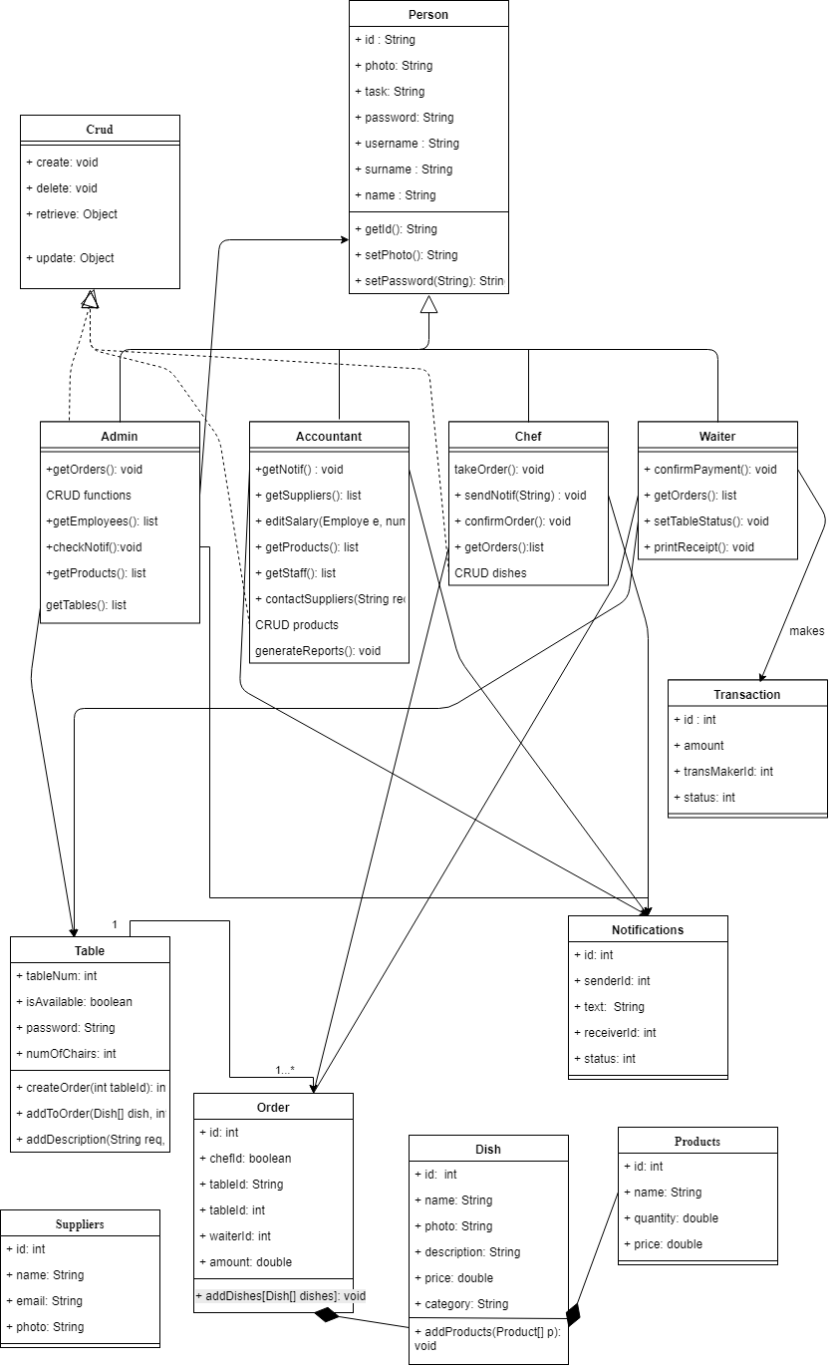

**USE-CASE DIAGRAM**

**WORKFLOW**

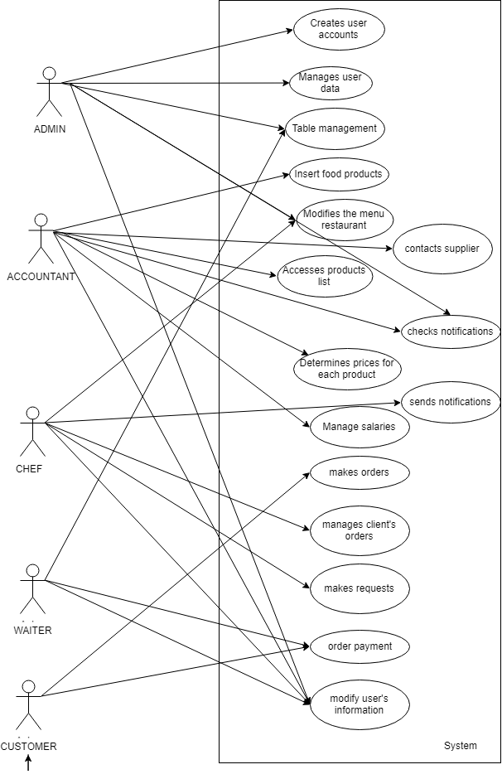

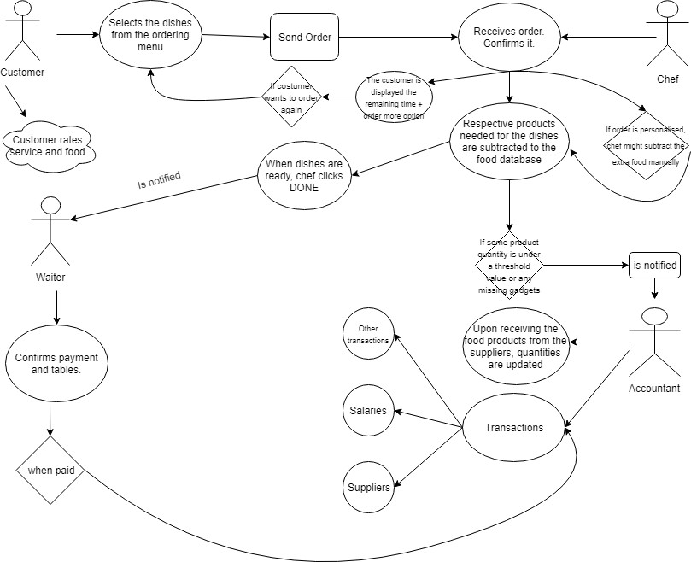



**Sequence Diagram**

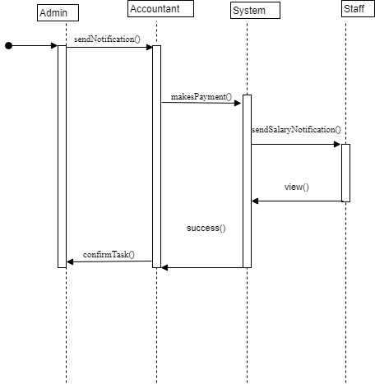

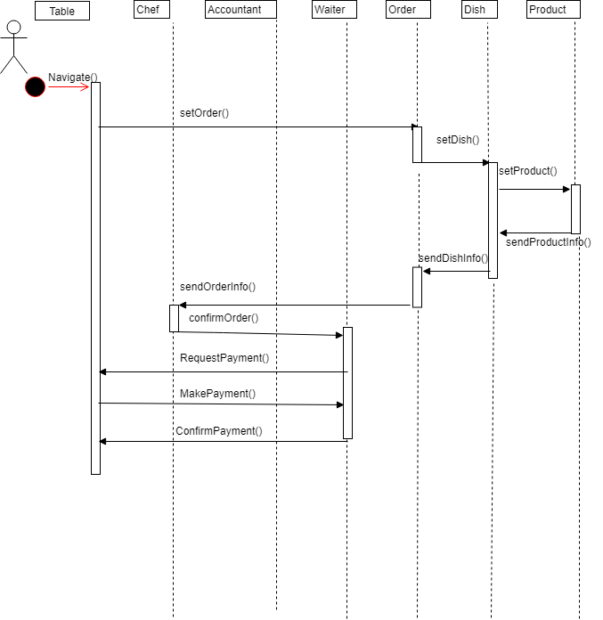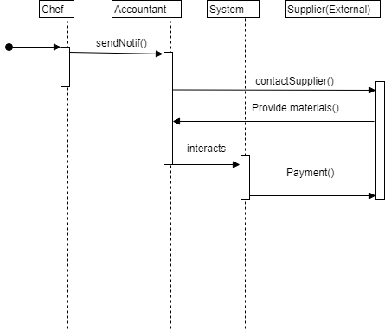

**Activity diagrams**

## Scenario 1-2

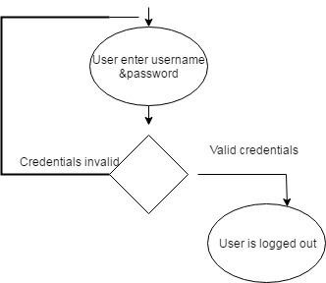

# Test Cases (Unit Tests) for Phase 1

Testing is a crucial aspect of software development. For our PHP project, we have devised unit tests that are designed to ensure the integrity and functionality of the primary features we've implemented in this phase. These test cases encompass the key components of the system and cater to both typical usage scenarios as well as edge cases.

## **1. User Registration Test Cases:**

### Test Case 1.1: Successful User Registration

* Purpose: To verify that a user can successfully register.
* Preconditions: The email "john@example.com" does not exist in the database.
* Steps:
* Navigate to the registration page.



* Input name="John Doe", email="john@example.com", password="Password123".
* Click the 'Register' button.
* Expected Outcome: A confirmation message, "Successful registration", is displayed, and user data is stored in the database. 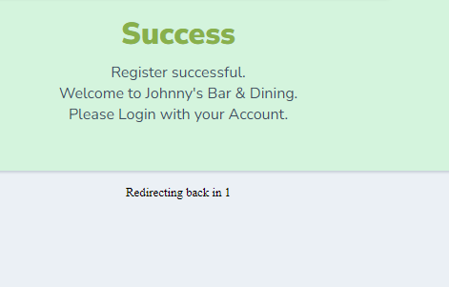

### Test Case 1.2: Registration with Existing Email

* Purpose: To ensure users cannot register with an email that already exists.
* Preconditions: The email "john@example.com" already exists in the database.
* Steps:
* Navigate to the registration page.
* Input name="Jane Smith", email="john@example.com", password="Password456".
* Click the 'Register' button.

Expected Outcome: An error message, "Email already exists", is displayed. 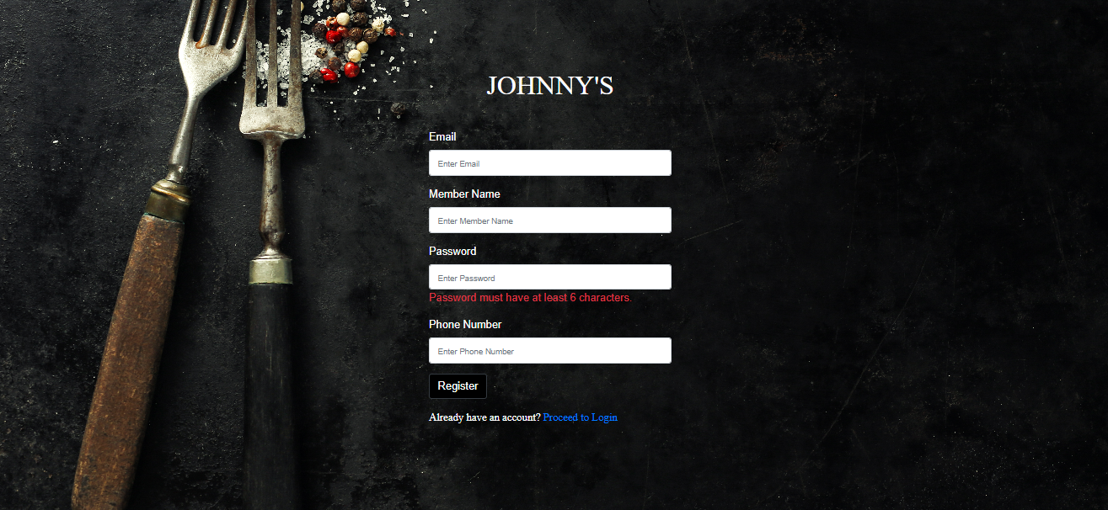

### Test Case 1.3: Registration with Invalid Email Format

* Purpose: To ensure users input a valid email format during registration.
* Steps:
* Navigate to the registration page.
* Input name="John Doe", email="john.com", password="Password123".
* Click the 'Register' button.
* Expected Outcome: An error message, "Invalid email format", is displayed. 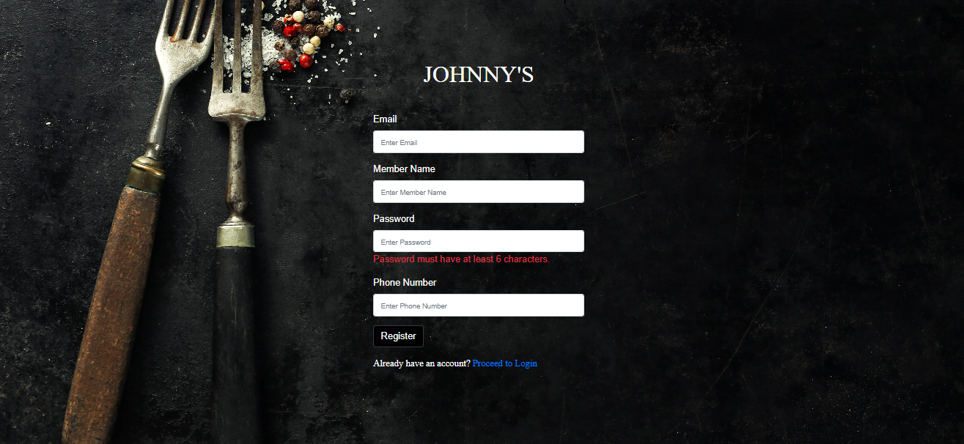

## **2. User Login Test Cases:**

### Test Case 2.1: Successful User Login

* Purpose: To verify that registered users can log in successfully.
* Preconditions: The user "john@example.com" exists in the database with the password "Password123".
* Steps:
* Navigate to the login page.
* Input email="john@example.com", password="Password123".
* Click the 'Login' button.
* Expected Outcome: User is successfully redirected to their dashboard. 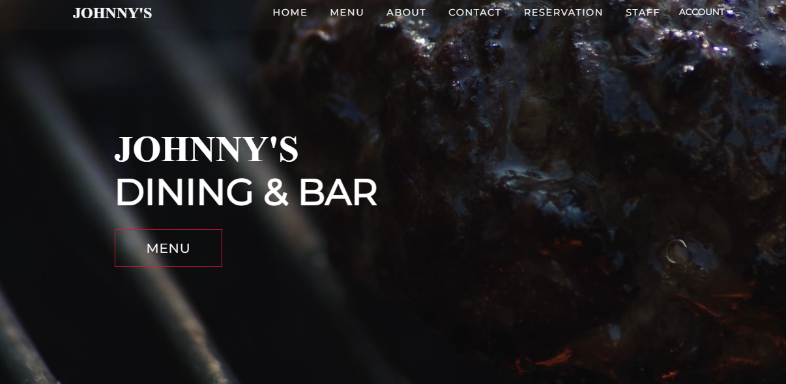

### Test Case 2.2: Login with Incorrect Password

* Purpose: To ensure users cannot log in with an incorrect password.
* Steps:
* Navigate to the login page.
* Input email="john@example.com", password="WrongPassword".
* Click the 'Login' button.
* Expected Outcome: An error message, "Incorrect password", is displayed.
* User Manual



# Introduction to the User Manual

This user manual is intended to guide both new and existing users through the process of navigating and using our PHP-based system. From installation to daily tasks, this guide aims to ensure a smooth experience for all users.

## **Installation Guide:**

Download Project: Start by downloading the PHP project zip from the official repository.

* Extract Project: Once downloaded, extract the project files into your local server environment. For instance, if you're using XAMPP, extract it to the htdocs directory.
* Database Setup: Launch your server's control panel (e.g., XAMPP Control Panel) and start the Apache and MySQL services. Then, open your web browser and navigate to PHPMyAdmin (usually localhost/phpmyadmin). Here, you will import the provided SQL file to establish the required database and tables.

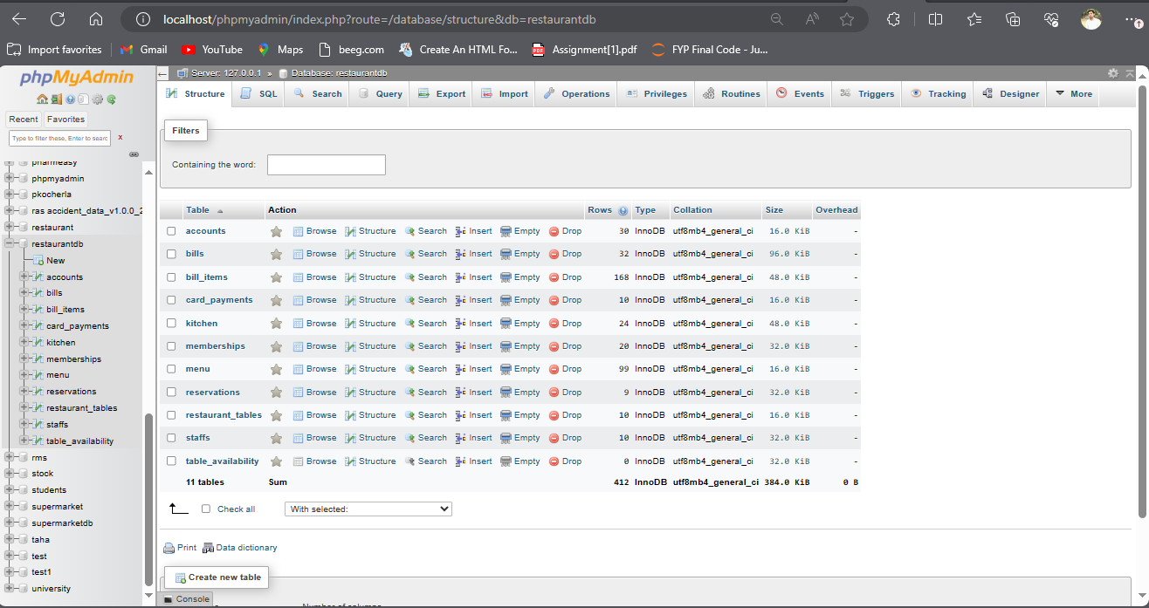

* Accessing the Application: With the database set up, navigate to localhost/your-project-folder-name on your web browser. This is where you can start interacting with the application.



## **User Interface Guide:**

### Registration and Login:

* Registration: If you're accessing the system for the first time, you'll need to register. Click on the 'Register' link or button on the homepage. This will take you to the registration form. Here, you will provide your name, a valid email address (which will also serve as your username), and a password. Once completed, click 'Submit' to create your account.

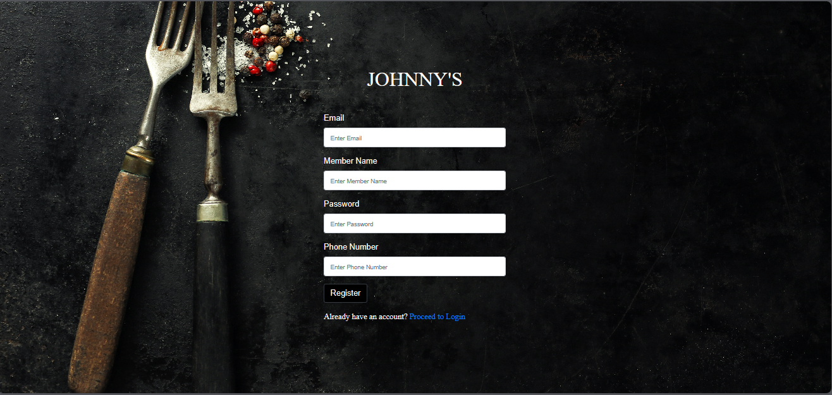

* Login: If you're a returning user, click on the 'Login' link or button on the homepage. Enter your registered email address and password. If the credentials are correct, you will be taken to your dashboard.

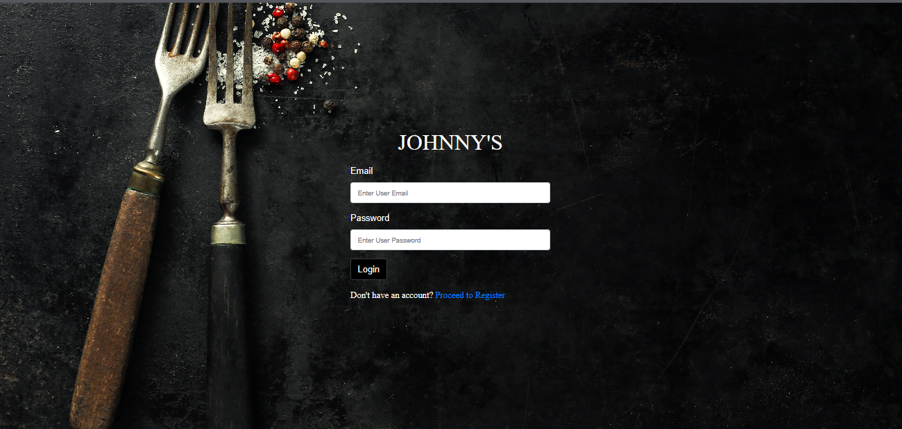

### 

### Dashboard and Profile Management:

* Dashboard Overview: After logging in, you'll be taken to your personal dashboard. This page provides an overview of recent activities, user statistics, and other pertinent information. You can navigate to other sections of the system using the navigation bar or menu.
* Profile Management: To update your profile details, navigate to the 'Profile' or 'Account Settings' section. Here, you can modify your name, email address, password, and other personal details. Always remember to save any changes you make.

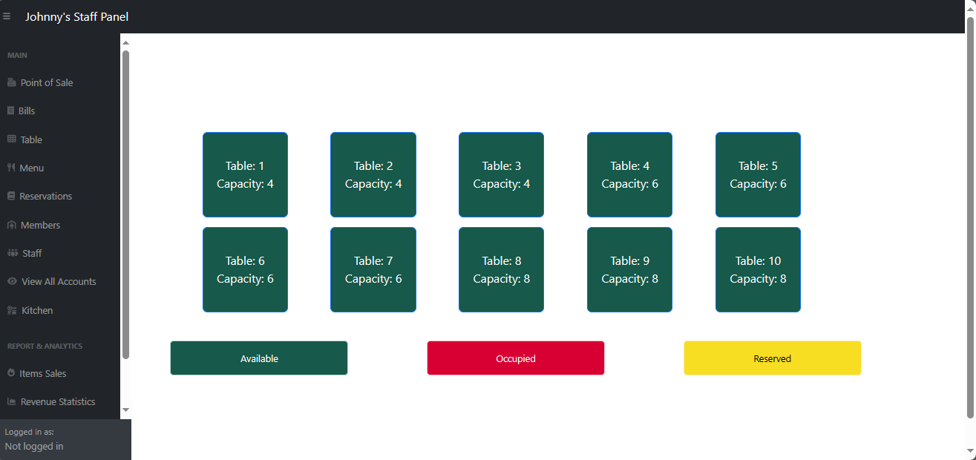

### 

### Troubleshooting:

* Forgotten Password: If you forget your password, click on the 'Forgot Password' link on the login page. Enter your registered email address, and you will receive instructions on how to reset your password.
* Data Not Loading: If certain data isn't displaying, ensure your server services (Apache and MySQL) are running. If the problem persists, contact your system administrator.

# Compilation Instructions

**Prerequisites:**

* PHP 7.4 or higher installed.
* MySQL Server running.
* Composer dependency manager installed.

**Steps:**

1. **Clone the Repository:** Clone the project repository from GitHub to your local machine.
2. **Install Dependencies:** Navigate to the project directory in your terminal and run **composer install** to install all necessary dependencies.
3. **Database Configuration:** Import the provided SQL file into your MySQL server to set up the required database tables.
4. **Edit Configuration Files:** In the **.env** file, update the database connection details to match your MySQL server configuration.
5. **Start the Server:** Navigate to the project's root directory in your terminal and run **php -S localhost: 3307**to start the PHP server.
6. **Access the Application:** Open your web browser and go to **http://localhost:3307** to access the application.

# Peer Review Feedback

**Feedback from Team Alpha:**

* **Positive Feedback:**
  + The user authentication system is robust and secure.
  + The dashboard design is intuitive and user-friendly.
* **Areas of Improvement:**
  + The error messages in the user registration system can be more descriptive.
  + The profile management system can benefit from additional functionalities, like adding a profile picture.

**Actions Taken:**

* Implemented more descriptive error messages based on feedback.
* Planned to integrate the profile picture functionality in Phase 2.

# Reflection

Our journey in Phase 1 of the project has been a learning curve. While our team started strong with a clear vision of our project's direction, we encountered unexpected challenges:

**What Went Well:**

* Strong team communication allowed us to brainstorm effectively and keep everyone on the same page.
* Our initial research and planning phase ensured that we had a clear roadmap.

**Challenges Faced:**

* Integrating the different modules, particularly the dashboard with the user registration system, was more challenging than anticipated.
* Balancing aesthetics with functionality in the dashboard design.

**Learnings:**

* The importance of setting intermediate milestones.
* The value of regular team check-ins to ensure alignment.

We remain optimistic and determined to tackle the upcoming phases with even more vigor, ensuring we incorporate our learnings from Phase 1.

## 

## **Improvements for Future Phases**

In the aftermath of Deliverable 3, as we took a moment to ponder on our journey, several key insights stood out that could pave the way for improvements in our subsequent phases. While we achieved a substantial amount of our set objectives, we also identified areas where our approach could be refined to enhance efficiency and output quality.

### 1. Communication:

Even though our team maintained a consistent communication flow, there were instances where certain decisions took longer due to awaiting feedback or validations. We need to adopt a more synchronous mode of communication, especially during crucial decision-making junctures.

### 2. Documentation:

While our documentation met the requirements, it became evident that we could have organized and structured it more effectively. A clearer distinction between different sections, utilization of tables, graphs, and visuals, and ensuring that all technical jargon is adequately explained can be areas of improvement.

### 3. Task Prioritization:

Although we implemented an incremental approach, there were scenarios where non-critical tasks consumed significant time. Going forward, we need to reassess our task prioritization strategies and ensure that critical tasks are always at the forefront.

### 4. User Interface and Experience:

From the feedback received, there are certain elements in our user interface that users found to be not very intuitive. We will be focusing on collecting more user feedback and refining the UI/UX to ensure a seamless experience for the end-users.

### 5. Testing:

While our test cases covered the core functionalities, there were edge cases that we missed. An expansion of our test suite and the integration of continuous testing tools can provide a more robust testing framework.

### 6. Peer Review Feedback Incorporation:

While we took into account most of the feedback from our peer reviews, a more structured approach to categorizing and systematically addressing this feedback would accelerate our iteration process.

### 7. Resource Allocation:

There were instances where certain team members were overloaded while others had bandwidth. A more dynamic approach to resource allocation, based on individual strengths, weaknesses, and current workloads, could enhance our team's efficiency.

### 8. Training:

Certain challenges faced during this phase were due to a lack of expertise in specific tools or technologies. Investing time in short training or knowledge-sharing sessions can mitigate such challenges in the future.

In conclusion, while we're proud of our accomplishments in Deliverable 3, the insights gained from this phase are invaluable. They've provided a clear roadmap for areas of improvement. Embracing these lessons will not only streamline our future endeavors but also enhance the quality of our deliverables. As a team, we are committed to continuous learning and improvement, and we believe that these reflections will be the catalyst for our enhanced performance in the upcoming phases

# Team Member Contribution Table

|  |  |  |  |
| --- | --- | --- | --- |
| Member name | Contribution description | Overall Contribution (%) | Note |
| Vangala Ruchitha | Team Leadership, Client Interactions | 15 |  |
| Nikhila Polkampally | Backend Development, Database Management | 15 |  |
| Nandhini Kasukurthi | Frontend Development, UI/UX Design | 10 |  |
| Vishal Rachuri | Testing, Quality Assurance | 10 |  |
| Sai Srinivas Valleti | System Analysis, Documentation | 10 |  |
| Chandralekha Gude | Project Coordination, Feedback Analysis | 10 |  |
| Aishwarya Karukonda | HR and Staff Training Coordination | 10 |  |
| Hunny Keshwani | Backend Development | 10 |  |
| Leela Varadatta Sai Addanki | Frontend Development, UI/UX Assistance | 10 |  |